Introduction to Inventory
​

​
Nirolite ' inventory features allows you to track the movement of your items as you perform your business transactions.

Inventory Features
The inventory module of Nirolite consists of the following features:
- Stock Movement: transaction that records the movement of Items to and from selected Locations.
- Shipment: transaction that records the movement of Items to a Customer after a sale has been made.
- Purchase Receipt: transaction that records the movement of Items from a Supplier after a purchase has been made.
- Stock Ledger: report that keeps a record of all the stock transactions.
- Stock Balance: report that displays the stock balance quantities.

Enabling Inventory
To enable inventory you will have to first check the Enable Inventory. To navigate: Setup > Settings > General Tab.
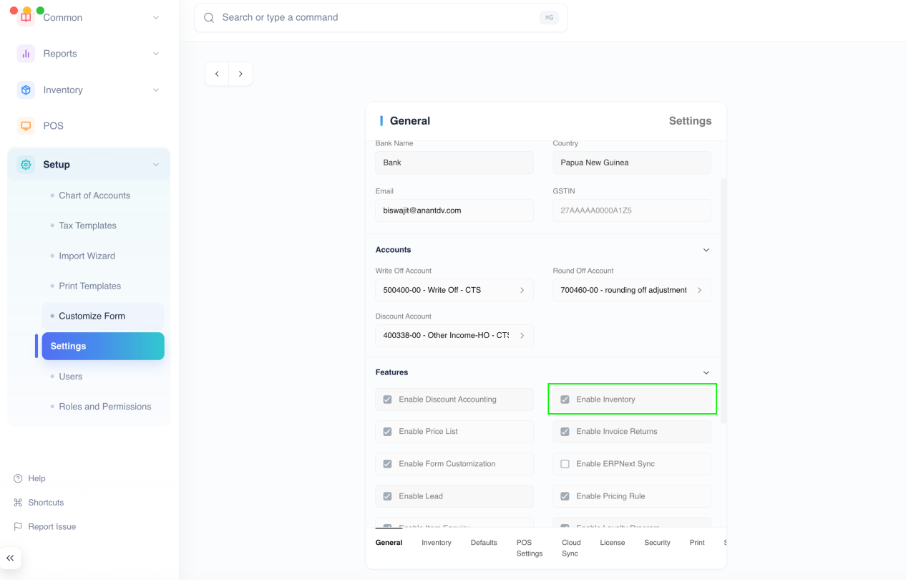
Once that is done you will have to restart Nirolite to see the Inventory item in the sidebar.
::: warning
Inventory cannot be disabled once it has been enabled. :::

Tracking an Item
Since you may not want to track the movement of all items, item tracking has to be enabled by setting the Track Item checkbox when creating an item.
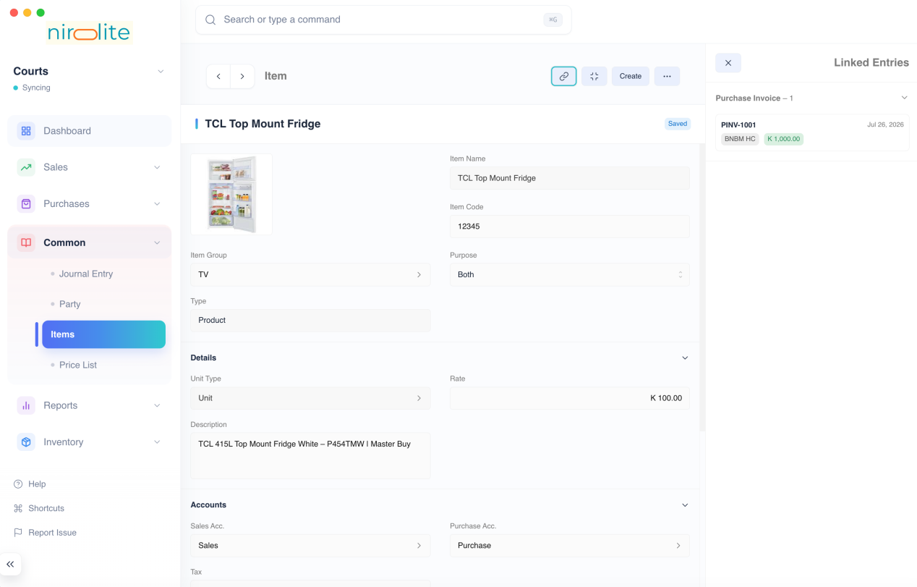
::: info
Track Item can be enabled only while creating the item. :::
Once you have created an item with tracking enabled, you can track its movement by making inventory specific transactions.

Location
In Nirolite the movement of an item takes place to and from a Location. There are two kinds of movements that can take place:
- Inward movement: When you move an item to a Location, the quantity of the item at that location increases.
- Outward movement: When you move an item from a Location, the quantity of the item at that location decreases.
The source or destination location for an outward or inward transaction is selected when making the transaction.
::: info Default Location
Nirolite has a default location called Stores set. This can be changed from the Inventory tab under Settings. :::
::: tip Creating Locations
Additional locations can be created when making an inventory transaction. To do so click the Create option in the Location selection dropdown. :::

Stock Quantity
Since an outward movement reduces the stock quantity at a location, if the location has an insufficient quantity of stock, the transaction will not be allowed.
This means that negative stock movement will not be allowed. This applies even to backdated entries that may cause negative stock in the future.
To enable the outward movement, two things can be done:
- Change the location to one that has sufficient quantity.
- Create an inward movement of the selected Item to the selected Location before the blocked transaction.
::: tip Stock Balance
To check which Location has sufficient quantity of an Item check the Stock Balance report. :::
Now that you know how to enable inventory and are familiar with the basic concepts, you can move onto reading about the inventory transactions.

Inventory Settings
​

​
Inventory settings will allow you to configure the inventory module to your requirements. To navigate to Inventory Settings: Setup > Settings then click on the Inventory tab
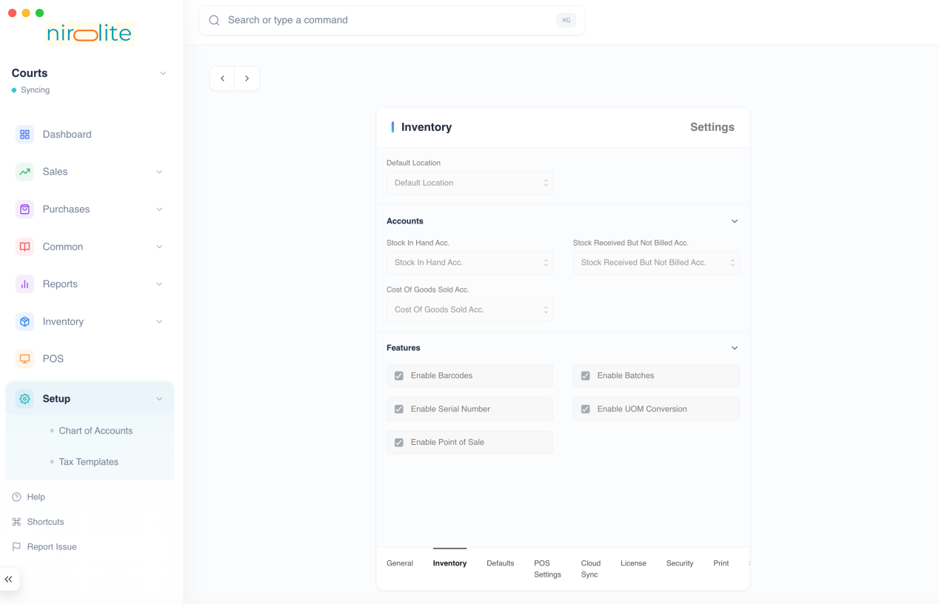

Setting Items
The following values can be configured

Valuation Method
This can be used to select either FIFO or Moving Average valuation methods.
The valuation rate displayed in the Stock Ledger or the Stock Balance report is calculated on the basis of the Valuation Method selected.

Default Location
This is used to set the location that is used whenever an inventory transaction detail is created.

Stock In Hand Account
This is used to set the default Stock In Hand Account that is debited whenever stock is received.

Stock Received But Not Billed Account
This is used to set the default Stock Received But Not Billed Account that is debited on making a Purchase Invoice for a tracked item, and credited when a Purchase Receipt is made.

Cost Of Goods Sold Account
This is used to set the default Cost of Goods Sold Account that is debited whenever a Shipment is made.

Enable Barcodes
Checking this will allow you to set barcodes on items. It will also display a barcode input in forms (such as Sales Invoice and Shipment) where items are entered.

Enable Batches
Checking this will allow the usage of Batches. Items will have a Has Batch option if the item is being tracked.
It will also enable the Batch entry type which can be navigated to by using the Quick Search.

Enable Serial Numbers
Checking this will allow the usage of Serial Numbers. Items will have a Has Serial Number option if the item is being tracked.
It will also enable the Serial Number entry type which can be navigated to by using the Quick Search.

Enable UOM Conversion
Checking this will allow setting multiple UOMs for an Items. Then when making a entry that involves the Item, one of the other UOMs can be selected to mention its quantity.

Enable Stock Returns
Checking this will allow you to create Purchase Receipt and Shipment Returns against the original Purchase Receipts or Shipments.

Stock Movement
​

​
Stock Movement is an inventory transaction that records the movement of stock to and from a location.
Unlike the other inventory transactions, stock movement is not linked to a Customer or a Supplier through a Sale or a Purchase.

Movement Types
Before creating a Stock Movement you need to know about its Movement Types. There are three types of Stock Movements that you can create:
- Material Issue: stock is moved out of a location.
- Material Receipt: stock is moved into a location.
- Material Transfer: stock is moved from one location to another.
- Manufacture: stock of items are moved out of a location and stock of different items are moved into a location.
Depending on the Movement Type you have to set the From and To movement locations
Movement Type | From | To
Material Issue | set | not set
Material Receipt | not set | set
Material Transfer | set | set
Manufacture | set | set
::: tip Manufacture For the Manufacture type, both From and To are set but for different items.
This reflects the stock movements of a manufacturing process where a set of raw materials are converted into finished goods.
The inventory quantities of the raw material will go down and that of the finished goods will go up. :::

Creating Stock Movements
To create a Stock Movement, first navigate to the stock movement List View: Inventory > Stock Movement then click on the blue + button in the title bar.
After clicking the blue + button:
- Select the Movement Type
- Add a row by clicking on Add Row
- Select an Item
- Select the movement locations
- Set the quantity and rate
- Click on Save and then on Submit
After clicking on submit the Stock Movement entry will be recorded.

View Stock Entries
New entries will be created in the Stock Ledger and the Stock Balance will be updated.
To View the Stock Ledger entries click on Stock Entries under the ... menu
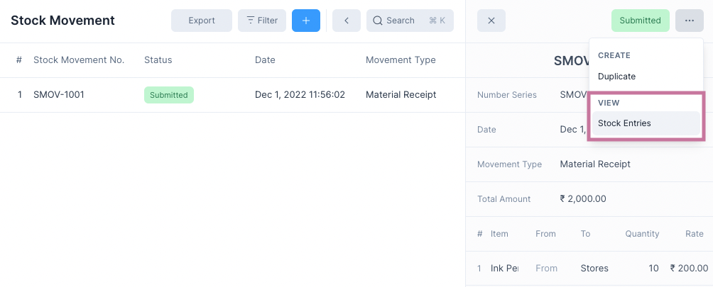

Purchase Receipt
​

​
Purchase Receipt is an inventory transaction that records the receipt stock from a supplier after a purchase has been made.
Purchase Receipts record inward movement of stock.
There are two ways to create a Purchase Receipt.

From a Purchase Invoice
Since a receipt of stock follows a purchase, you can create a Purchase Receipt after submitting a Purchase Invoice.
To do this select Purchase Receipt from under the Create menu button.
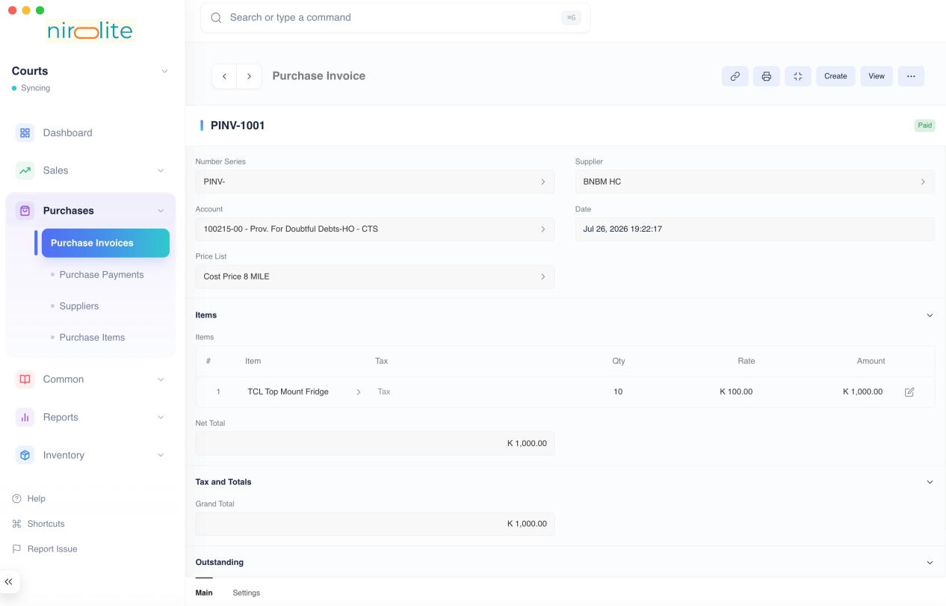
::: tip Back Reference
This will create a Purchase Receipt with a reference to the Purchase Invoice and allows you to view all created Purchase Receipts from the Purchase Invoice. :::

From the List View
To do this first navigate to the Purchase Receipt page: Inventory > Purchase Receipt then click on the blue + button.
The creation method is shared with with other transactional entries, for more information check this link.
::: warning No Back Reference
This method doesn't create links to any Purchase Invoices and is an isolated entry. :::

Purchase Receipt Form
After selecting one of the above two methods of creating a Purchase Receipt, you will see the Purchase Receipt form.
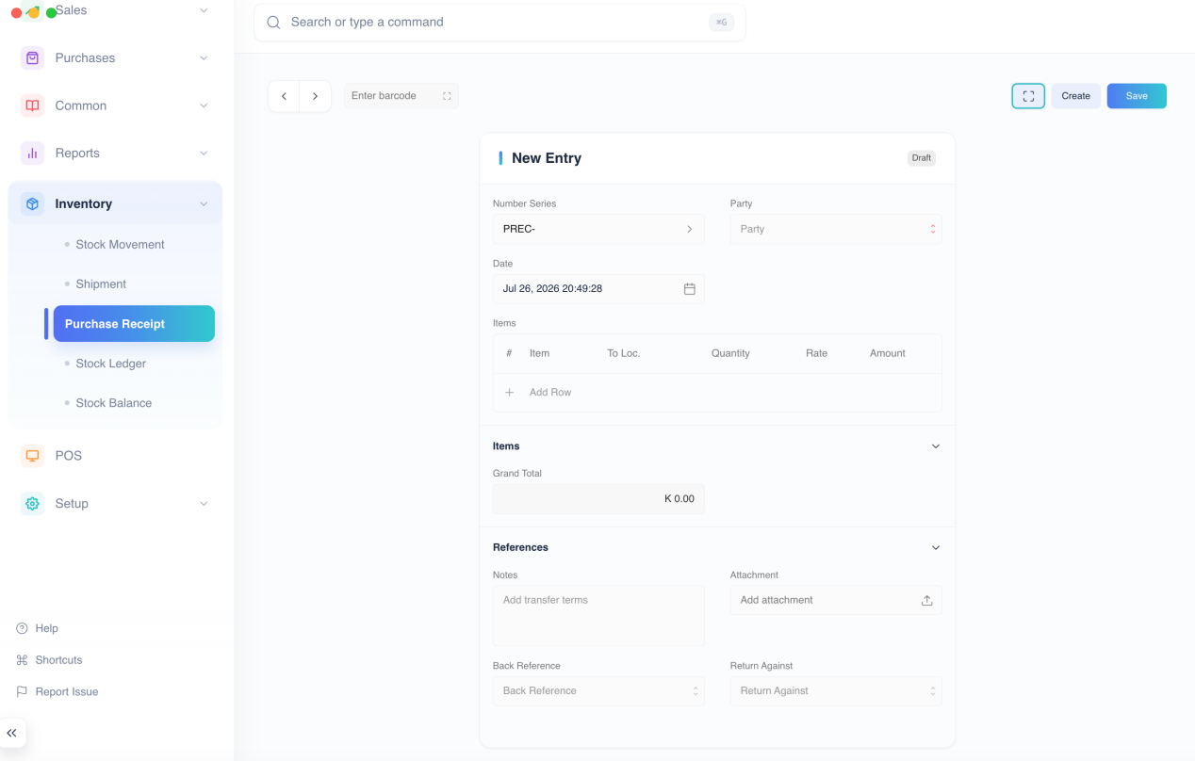
If you created the Purchase Receipt from a Purchase Invoice, all the rows will be filled out for you. Else you will have to enter the Purchase Receipt details.
Once the Purchase Receipt details have been entered, click on Save and then Submit to make the Purchase Receipt entry.
A Purchase Receipt can have one of the four following statuses:
Status | Description
Submitted | Purchase Receipt entry submitted
Return | Purchase Receipt Return entry submitted
Return Issued | Return entry created against Purchase Receipt
Cancelled | Purchase Receipt entry cancelled

Purchase Receipt Return
If you created a Purchase Receipt for an item that you returned, you can create a Purchase Receipt Return entry to reflect the return.
A Purchase Receipt Return entry can be created from an existing Purchase Receipt entry that has been submitted or from a new Purchase Receipt entry.

Enable Stock Returns
To create Purchase Receipt Returns the Stock Returns feature needs to be enabled. To do this, check the Enable Stock Returns option in Inventory Settings under the Features section.

Creating a Purchase Receipt Return
- Open the Purchase Receipt entry to be returned.
- Click on Create > Return. 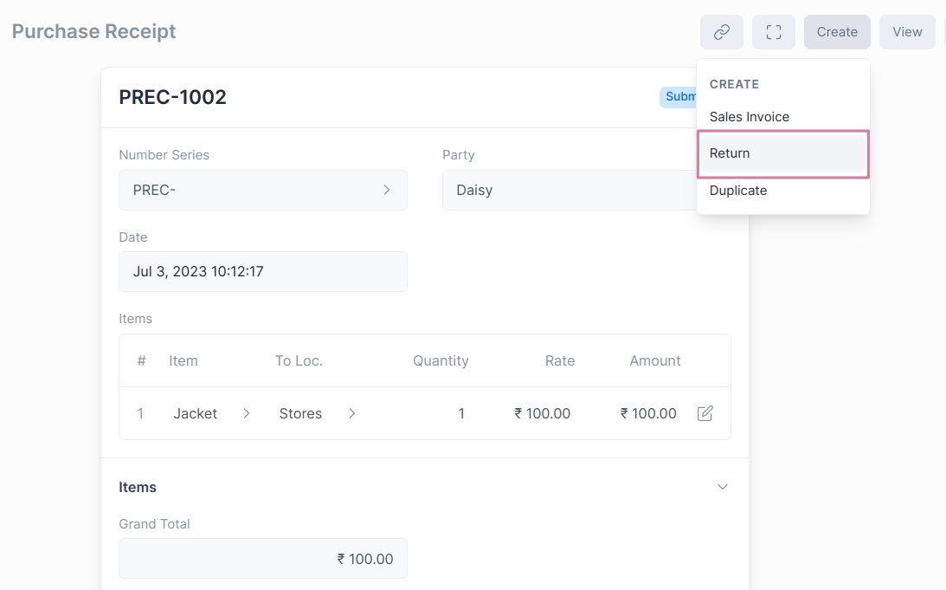
- The Party and Item details will be fetched from the original Purchase Receipt entry. You can set the quantity of Items returned. 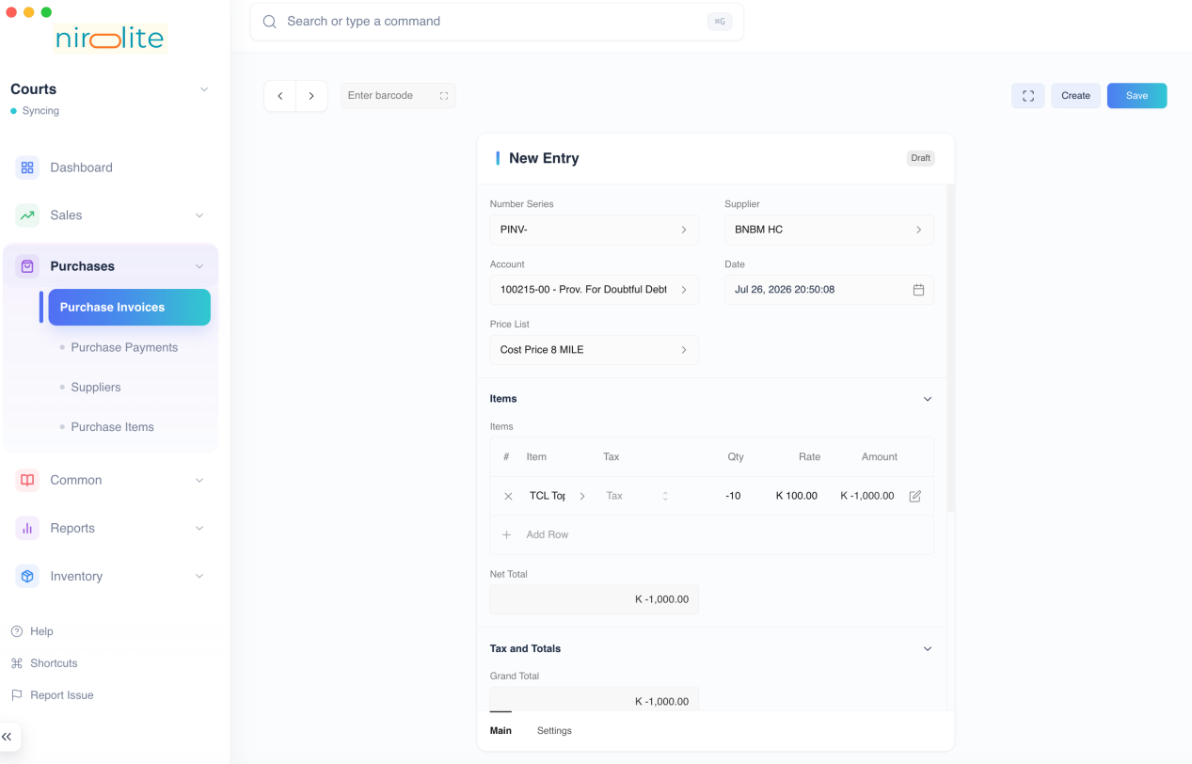
- Save and Submit.
::: info Item quantity and Payment amount will be in negative to indicate that it is a return. :::

How does Purchase Receipt Return affect General Ledger
The Purchase Receipt Return entry will create General Ledger entries to reverse the impact of the original Purchase Receipt.
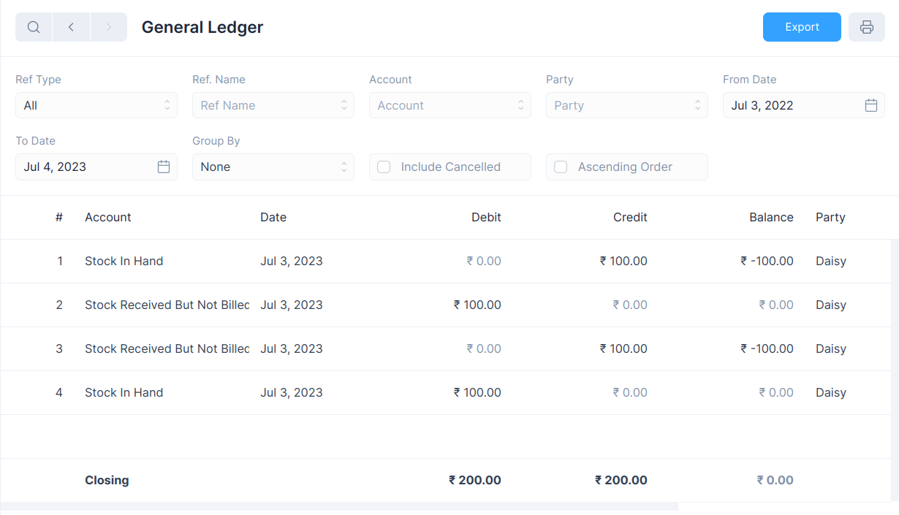

View Ledger Entries
After a Purchase Receipt is submitted, both Stock Ledger and General Ledger entries are created.
To view these you can click on the View button and select the one you would like to see.
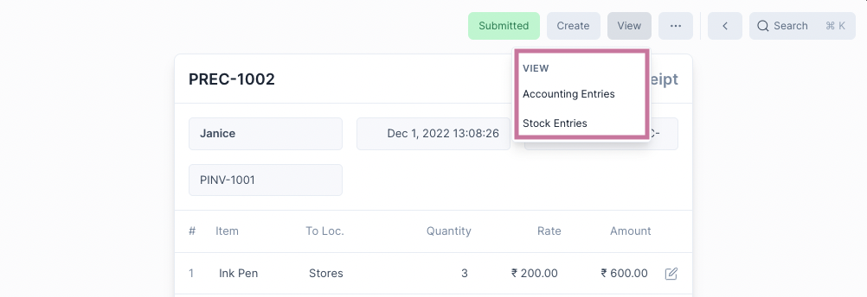

Shipment
​

​
Shipment is an inventory transaction that records the delivery of stock to a customer after a sale has been made.
Shipments record outward movement of stock. Hence a shipment can take place only if there is sufficient quantity of an Item at the selected Location.
There are two ways to create a Shipment.

From a Sales Invoice
Since a shipment of stock follows a sale, you can create a Shipment after submitting a Sales Invoice.
To do this select Shipment from under the Create menu button.
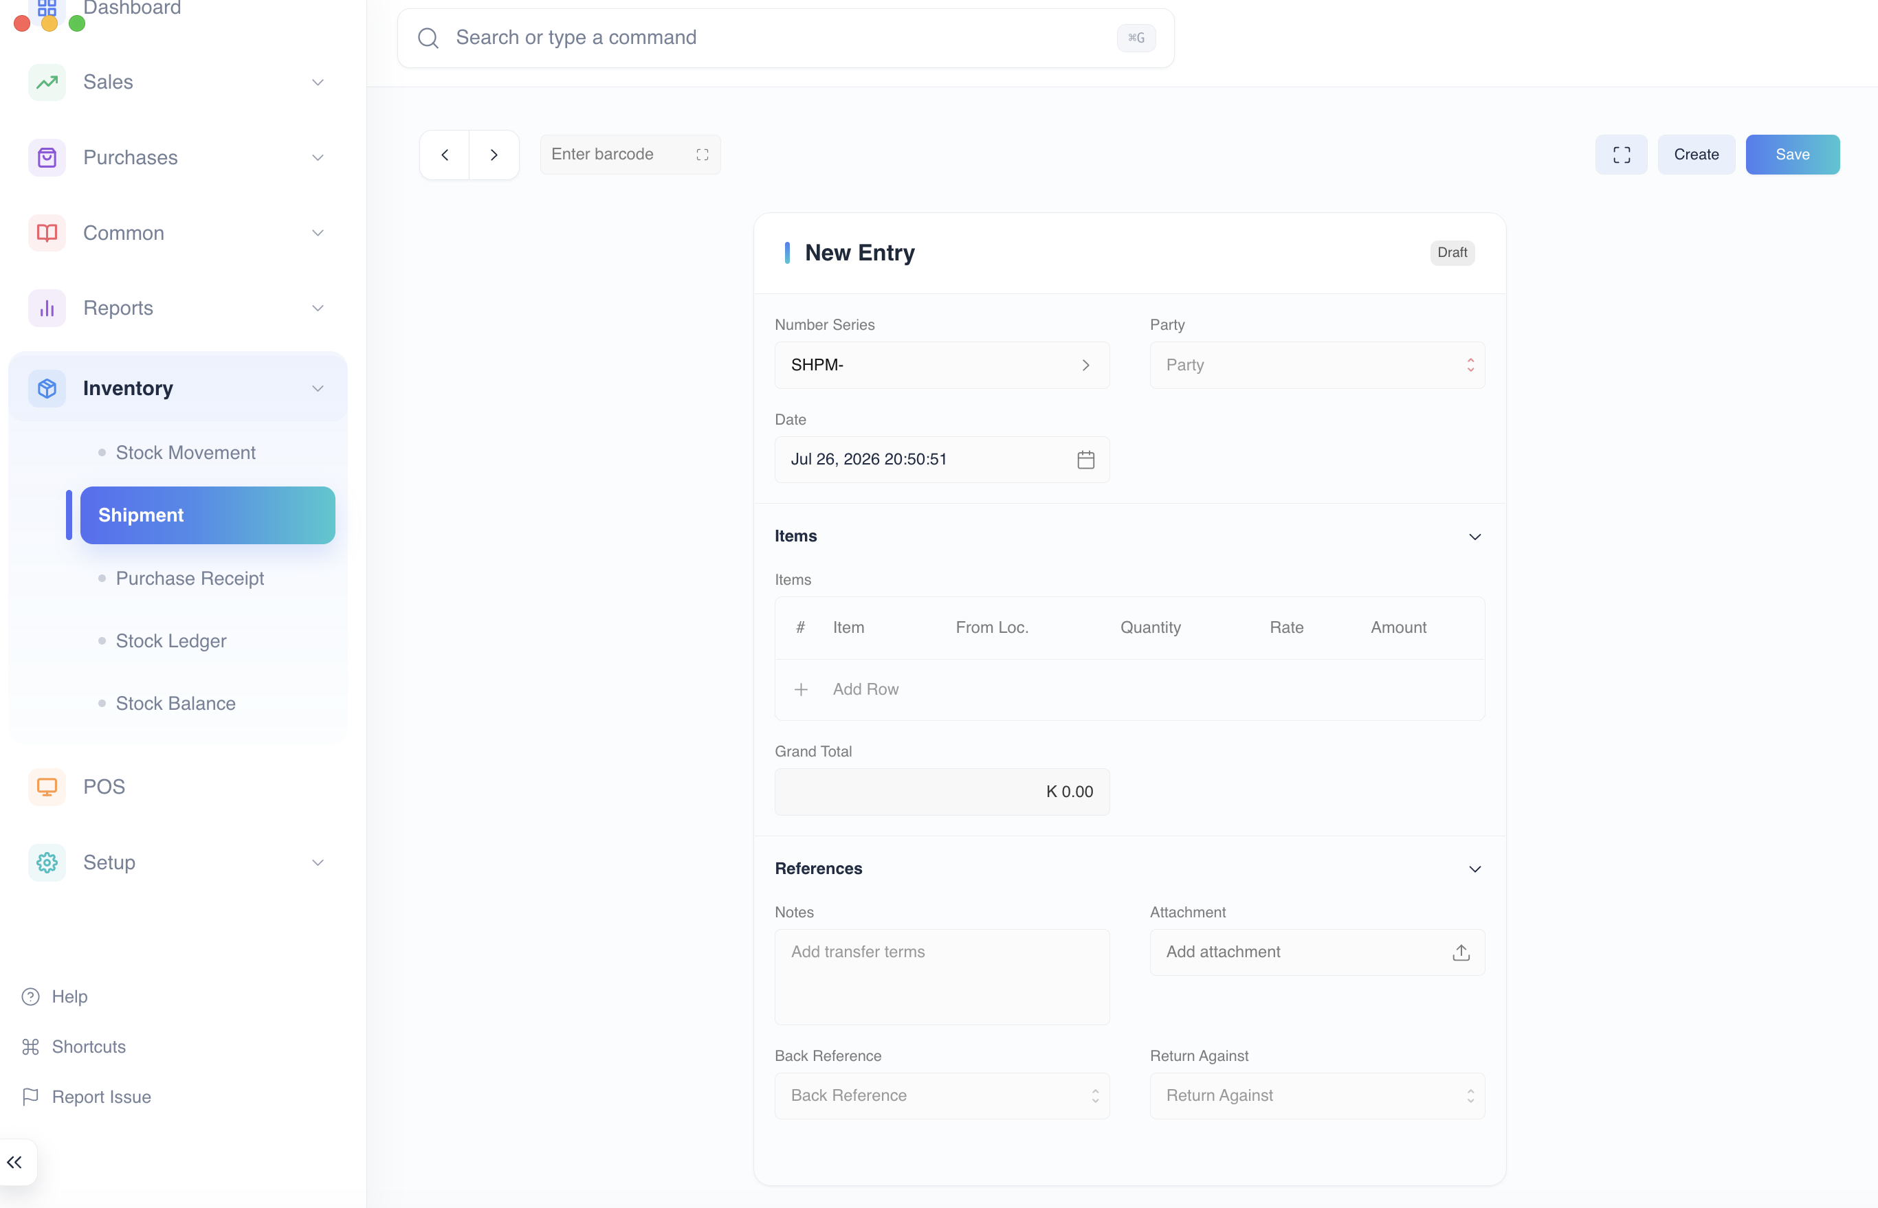
::: tip Back Reference
This will create a Shipment with a reference to the Sales Invoice and allows you to view all created Shipments from the Sales Invoice. :::

From the List View
To do this first navigate to the Shipment page: Inventory > Shipment then click on the blue + button.
The creation method is shared with with other transactional entries, for more information check this link.
::: warning No Back Reference
This method doesn't create links to any Sales Invoices and is an isolated entry. :::

Shipment Form
After selecting one of the above two methods of creating a Shipment, you will see the Shipment form.
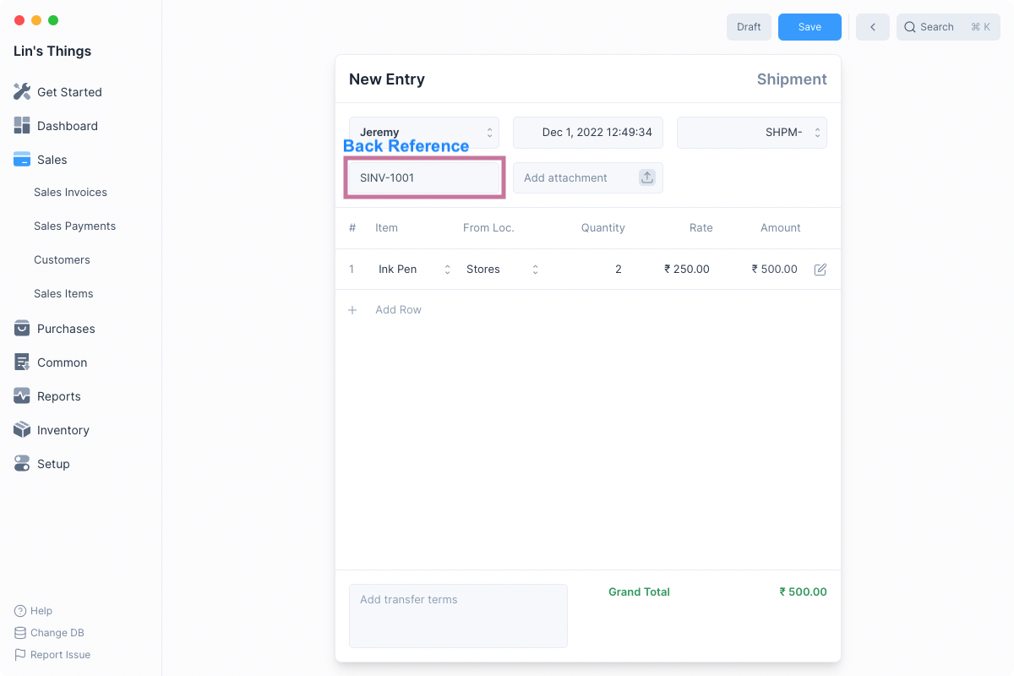
If you created the Shipment from a Sales Invoice, all the rows will be filled out for you. Else you will have to enter the Shipment details.
Once the Shipment details have been entered, click on Save and then Submit to make the Shipment entry.
A Shipment can have one of the four following statuses:
Status | Description
Submitted | Shipment entry submitted
Return | Shipment Return submitted
Return Issued | Return entry created against Shipment
Cancelled | Shipment entry cancelled

Shipment Return
The customer can return an already shipped Item due to quality issues, delay in delivery, or some other issue.
To reflect this you can create a Shipment Return from the original Shipment entry or manually create one from a new Shipment Entry.

Enable Stock Returns
To create Shipment Returns the Stock Returns feature needs to be enabled. To do this, check the Enable Stock Returns option in Inventory Settings under the Features section.

Creating a Shipment Return
- Open the Shipment entry to be returned.
- Click on Create > Return. 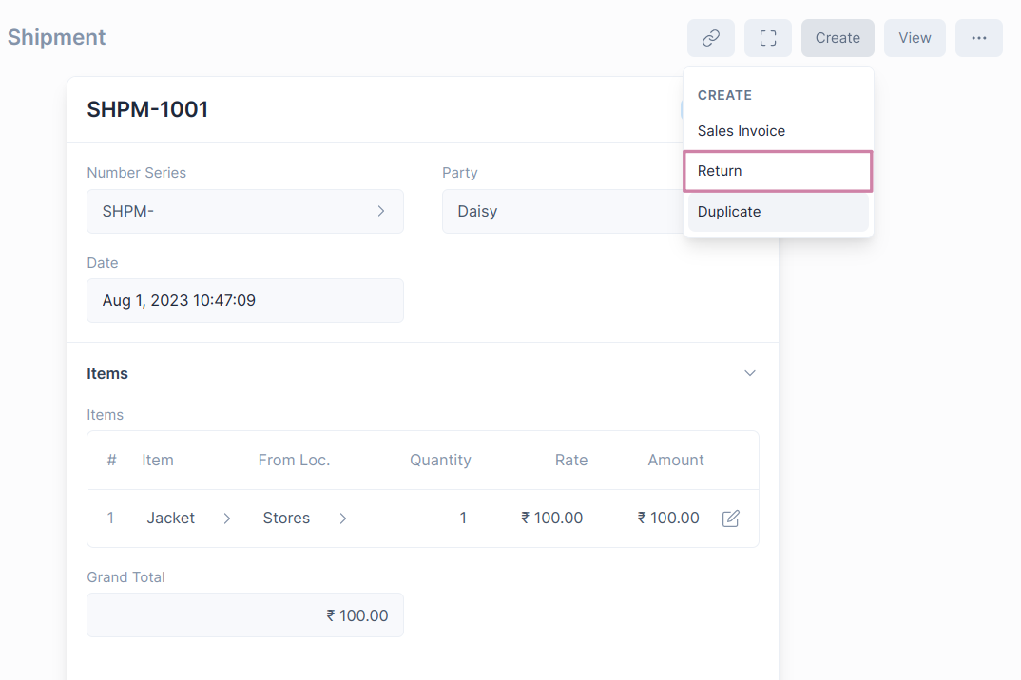
- The Party and Item details will be fetched from the original Shipment entry. You can set the quantity of Items returned. 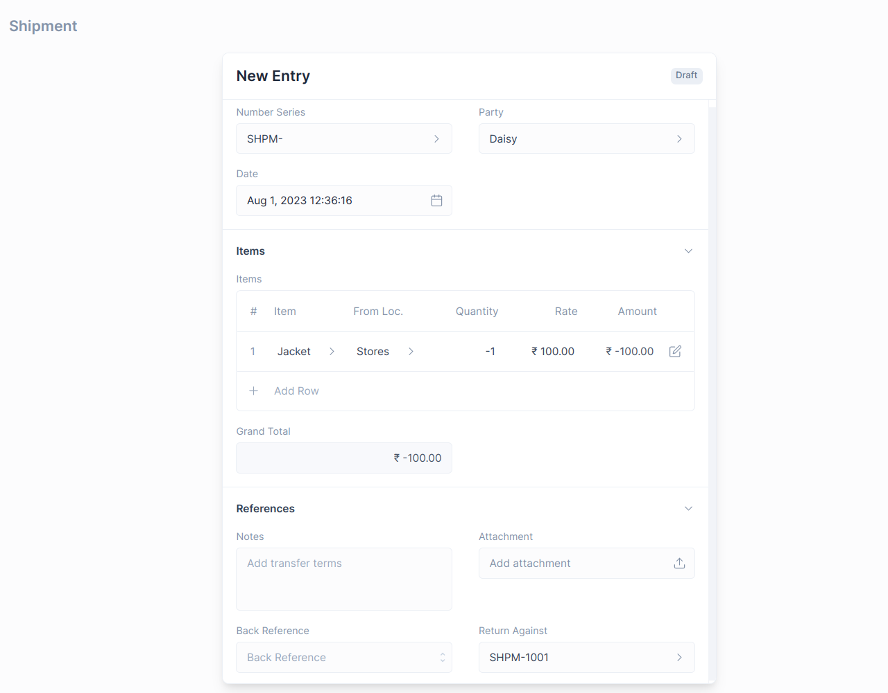
- Save and Submit.
::: info Item quantity and Payment amount will be in negative to indicate that it is a return. :::

Shipment Return impact on General Ledger
The Shipment Return entry will create General Ledger entries to reverse the impact of the original Shipment.
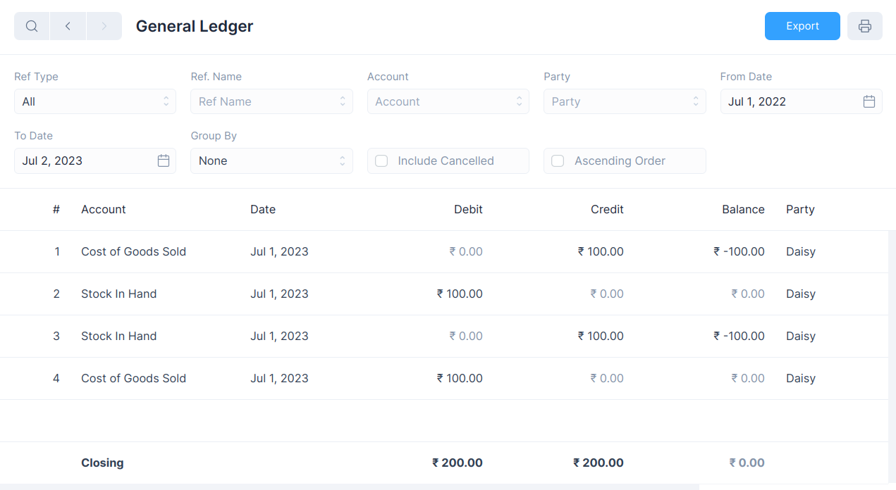

View Ledger Entries
After a Shipment is submitted, both Stock Ledger and General Ledger entries are created.
To view these you can click on the View button and select the one you would like to see.
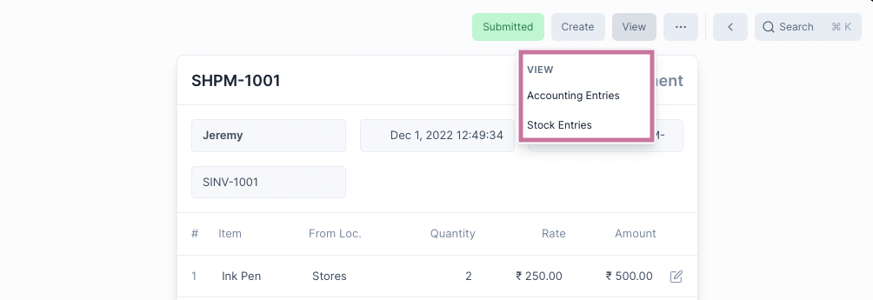

Serial Number
​

​
If an Item is serialized, a Serial Number record is maintained for each unit of quantity of that Item. This information helps to track the location of the Serial Number. The Serial Number status will tell you its current Inventory status.
The Serial Number feature needs to be enabled first by checking the Enable Serial Number option under Inventory Settings
To navigate to the list of Serial Numbers, open Quick Search and then type "serial number list" and select the first option.

Serialized Items
Once you've enabled Serial Number, you can mark an item as a serialized item by first checking Track Item and then Has Serial Number
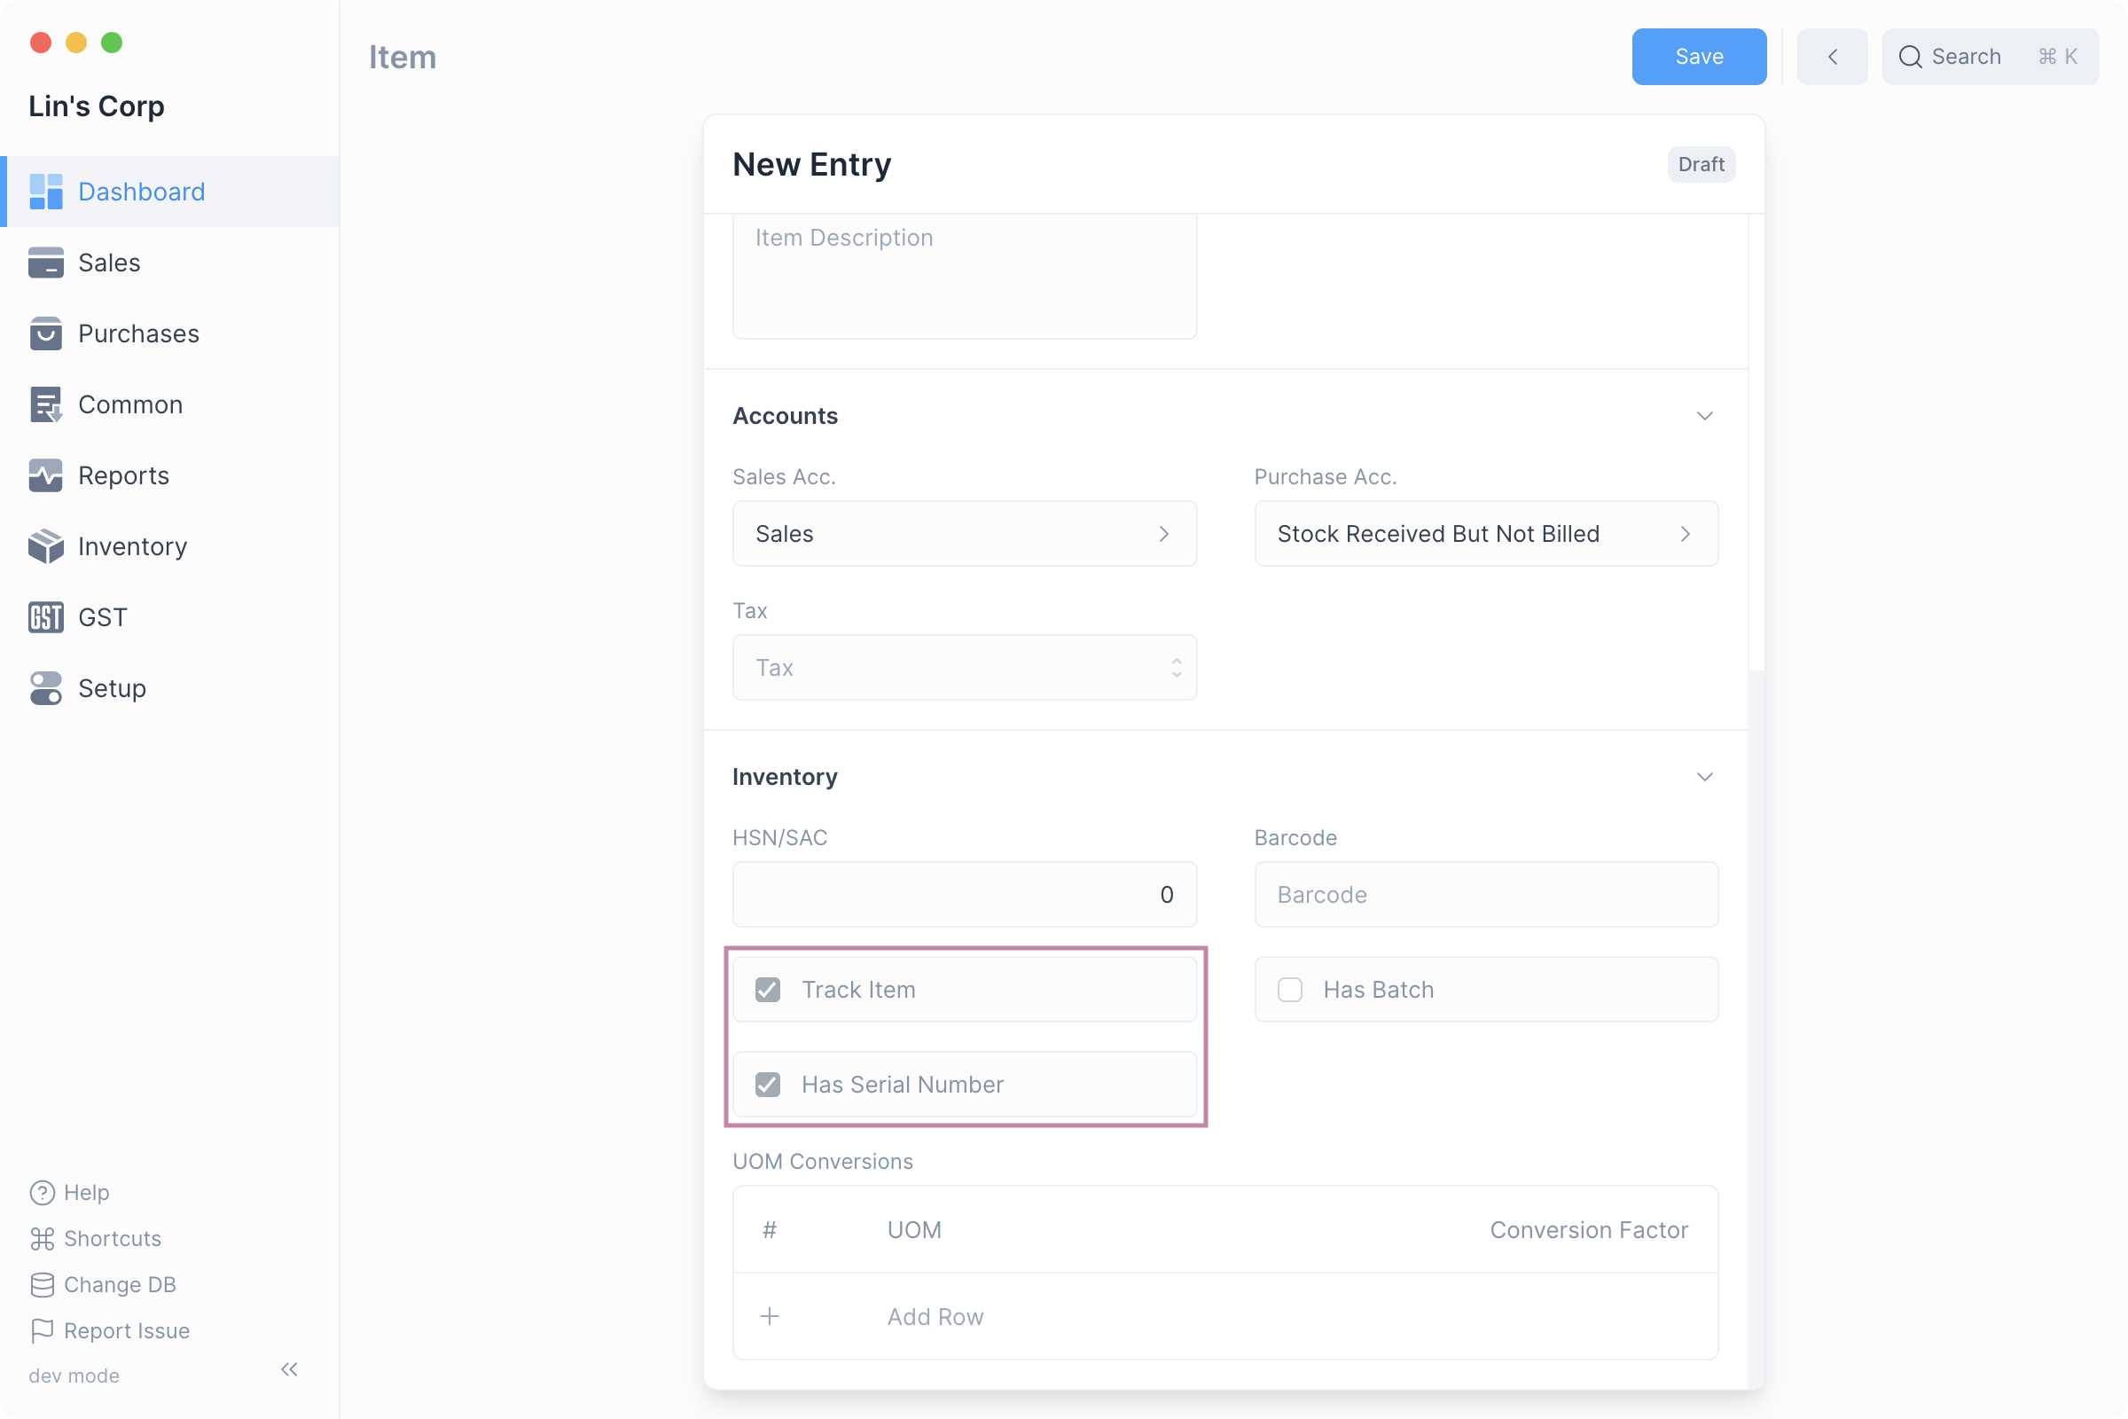
::: info Track Item Has Serial Number can be enabled only if Track Item is set. :::

Mentioning Item Serial Number
Once a Serial Number has been enabled for an Item, transactions involving the Item that update Inventory (such as Stock Movements, Shipments, and Purchases) must include the Serial Number.
This can be done by clicking the edit button on the table row and entering the Serial Number one per quantity.
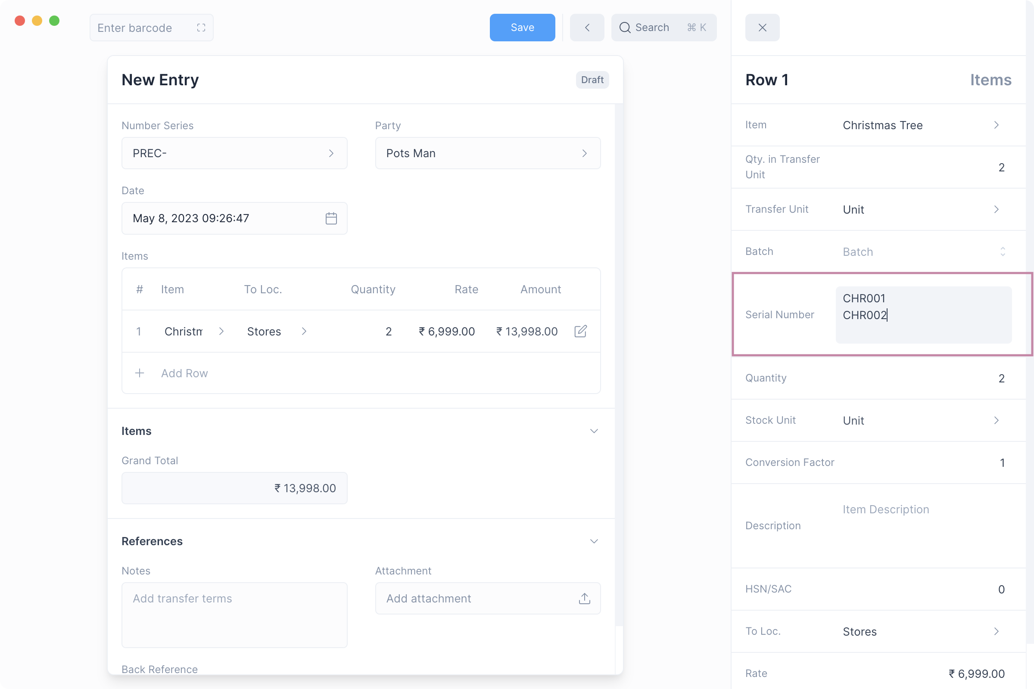
::: info Serial Number Entry For each unit of quantity of a serialized Item a single Serial Number should be provided on a separate line. :::

Serial Number Status
The status of a Serial Number changes depending on whether the transaction is an inward transaction (eg Purchase Receipt), or an outward transaction (eg Shipment).
A Serial Number can have one of three Status:
Status | Description
Active | Serial Number is in stock and can be used only for outward transactions.
Inactive | Serial Number is not in stock and can be used only for inward transactions.
Delivered | Serial Number has been used for an outward transaction and cannot be used.
Here is a table that shows how the status of a Serial Number changes:
Status Change | Transaction
Inactive → Active | Inward transactions: Material Receipt or Manufacture (created) Stock Movement, Purchase Receipt
Active → Delivered | Outward transactions: Material Issue or Manufacture (used up) Stock Movement, Shipment
If a transaction is cancelled then the Serial Number status is reverted.

Batches
​

​
Inventory in Nirolite can be maintained on the basis of Batches. Here a Batch of some Item is a uniquely grouped collection of those Items.
The Batch feature needs to be enabled first by checking the Enable Batches option under Inventory Settings.
To navigate to the list of Batches, open Quick Search and then type "batch list" and select the first option.

Batched Items
Once Batch has been enabled, you can mark an Item as a Batched Item by first checking Track Item and then Has Batch.

::: info Track Item
Has Batch can be enabled only if Track Item is set. :::

Mentioning Item Batch
Once Batch has been enabled for an Item, transactions involving the item that update inventory such as Stock Movements, Shipments and Purchase Receipts will require mentioning the Item's Batch.
This can be done by clicking the edit button on the table row and selecting the batch.
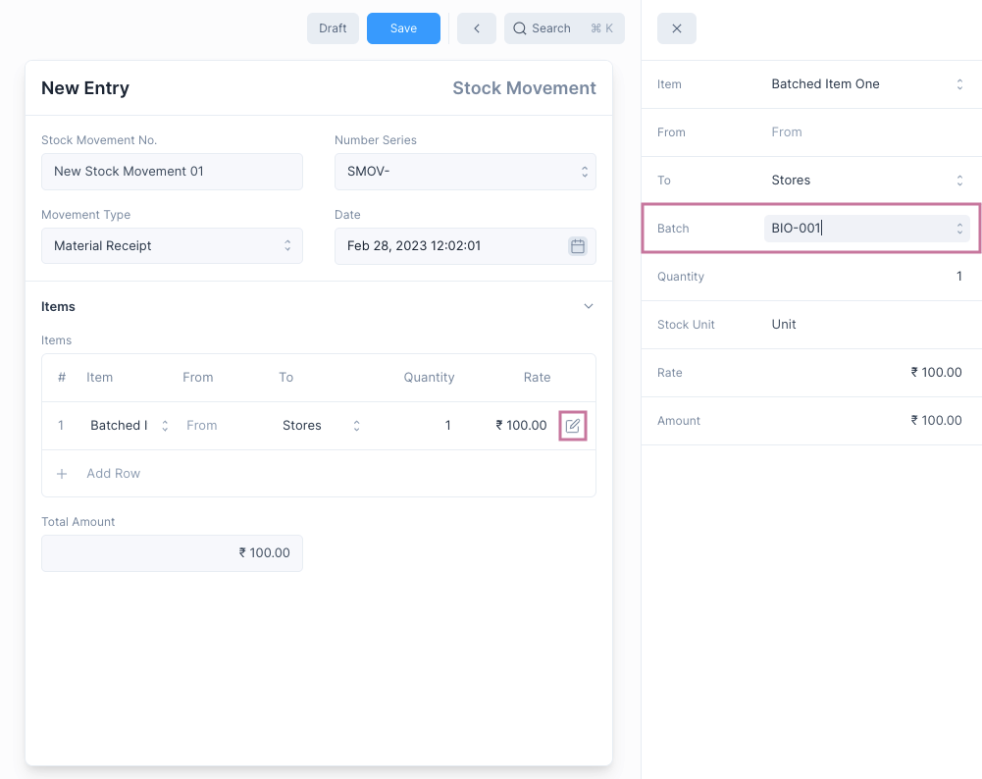

Batch-wise Reports
After batches have been enabled, the inventory reports i.e. Stock Ledger and Stock Balance will both have an additional column that mentions the Item's Batch.
You can also set Batch specific filters to show information that relates only to the selected Batch.
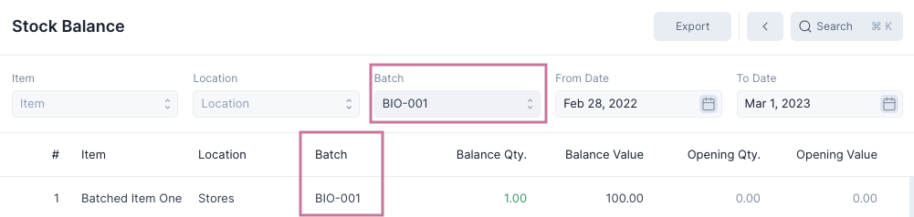

Stock Ledger
​

​
Stock Ledger is a report that displays all the stock entries that are recorded whenever an inventory transaction such as a Shipment or a Stock Movement is submitted.
The Stock Ledger shows you the change in quantity, value and valuation rate over the course of various inventory transactions.
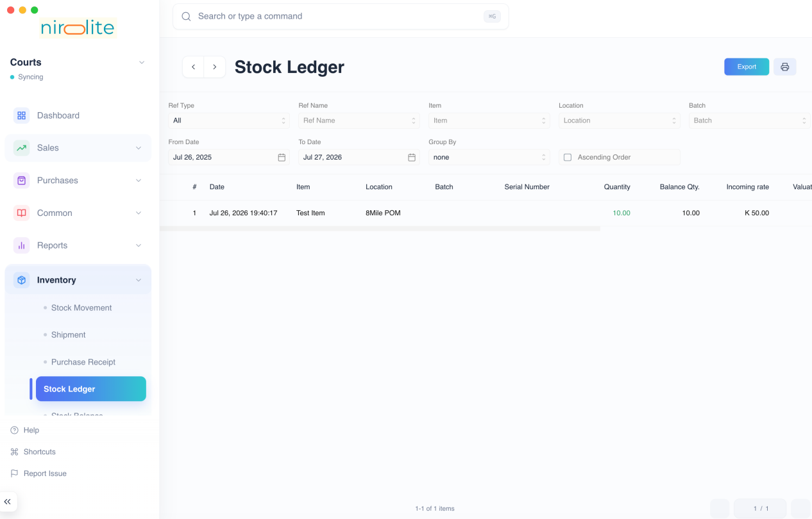

Filters
The Stock Ledger has several filters which can help you narrow the generated report to the entries you would like to see.

Ref Type
Setting Ref Type as anything other than All will display entries only of that Transactional entry type.
Example setting Ref Type as Shipment will display only entries created due to Shipment.

Ref Name
Ref Name filter allows to display all ledger entries that were generated due to a single Transactional Entry.
To enable this you need to first set Ref Type.

Item
Selecting a Item will display only entries involving the selected item.

Location
Selecting a Location will display only entries involving the selected location.

From Date
The initial date after which all the entries are to be displayed. The default value is one year before tomorrow.

To Date
The final date before which all the entries are to be displayed. The default value is one day after today.

Group By
Selecting a Group By option other than None groups the entry according to the selected option.
For instance setting Group By as Reference will group the entries by the Name of the Transactional entry.

Ascending Order
By default the entries are displayed by newest entry first, i.e. descending order of Date.
Checking this will display the entries in ascending order of entry date.

Stock Balance
​

​
Stock Balance is a report that displays the current stock quantities, value and valuation rate by Item and Location.
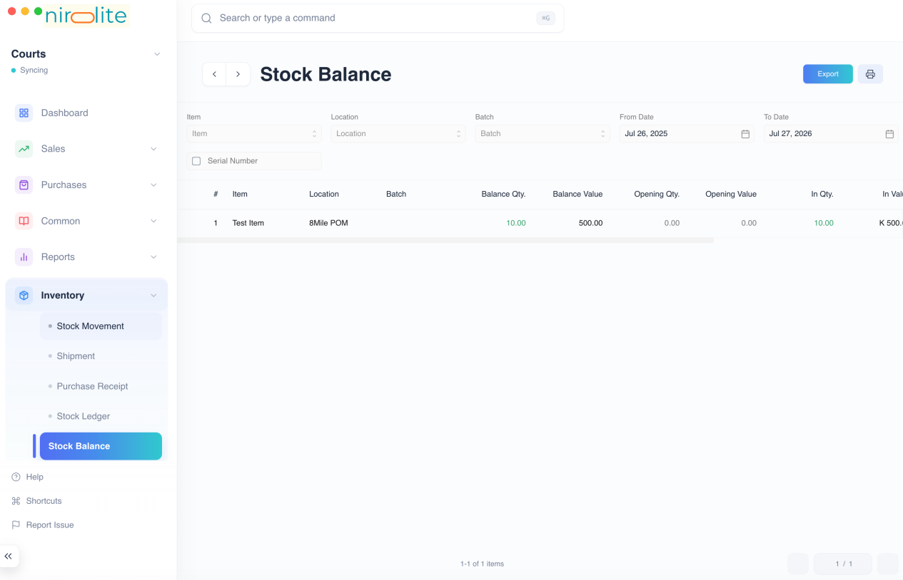

Filters
The Stock Balance has filters which can help you narrow the generated report to the entries you would like to see.

Item
Selecting a Item will display only entries involving the selected item.

Location
Selecting a Location will display only entries involving the selected location.

From Date
The date from which all the stock balance is calculated. The default value is one year before tomorrow.
Stock balance from before this date is used to set the Opening Quantity and Opening Value.

To Date
The date until which all the stock balance is calculated. The default value is one day after today.
Values after this date are ignored.
::: tip
If you are getting insufficient quantity for backdated inventory entries, you can use this filter to identify future negative quantity. :::

